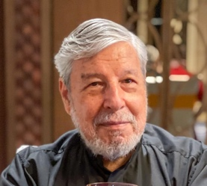

PP Maneiras Joe C da Silva

I joined the Rotary Club of Macau on 27th July 1966, just 56 years ago! Back in those days Rotary International was only 61 years old having been formed in 1905. Back in those days we were in District 345 which covered Hong Kong, Macao and Taiwan. We were the second oldest club in the District following Rotary Club of Hong Kong.

Back then there was no other clubs in Macao, no Rotaract, no Interact and the club was all male. We would have a ladies night once or twice a year. Since then we have seen major changes over the years and now we are seeing Jennifer Jones becoming a Rotary International President.
I became President of our club in 1985. As incoming President you need to attend the District Conference. That year it was in Taipei and there I met Rotary Club of Taipei incoming District Governor Gary Huang. Gary later became President of Rotary International. I met him again in August 2014 when he came to Macao for our Joint Area Meeting at the Venetian.

